**WEEK 3 HANDSON - SPRING DATA JPA WITH HIBERNATE :**

**Spring Data JPA - Quick Example**

**TASKS :**

1. **Create a Project using Spring Initializr**
2. **Country table creation**
3. **Persistence Class - com.cognizant.orm-learn.model.Country**
4. **Repository Class - com.cognizant.orm-learn.CountryRepository**
5. **Service Class - com.cognizant.orm-learn.service.CountryService**
6. **Testing in OrmLearnApplication.java**

**CODES AND OUTPUTS :**

1. **Create a Project using Spring Initializr**

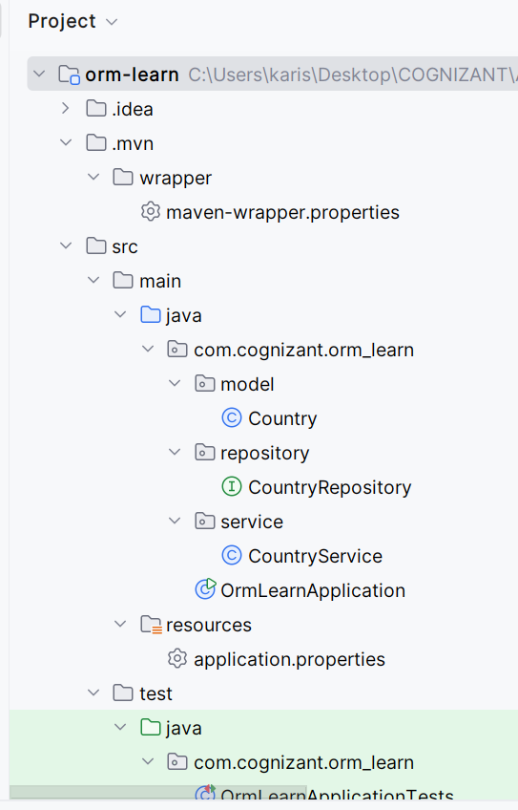

1. **Country table creation**

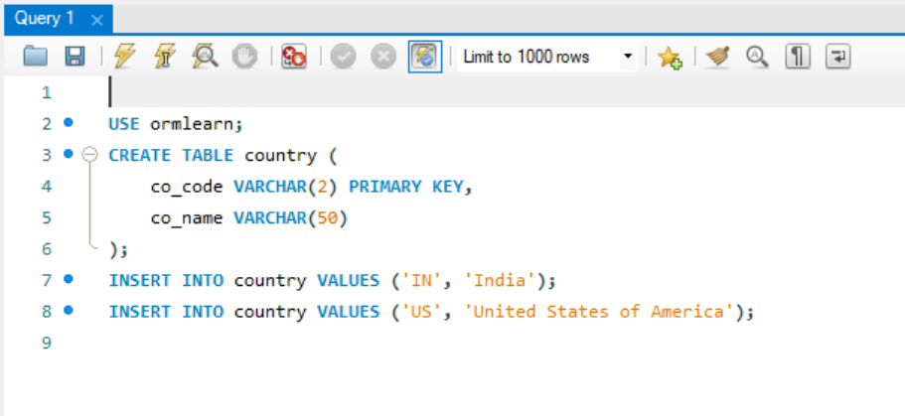

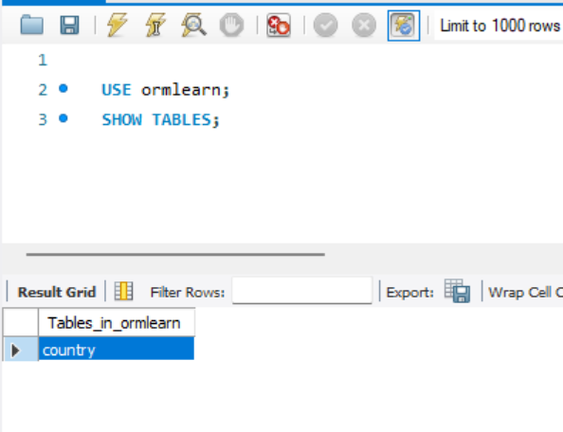

**Step 3 : Persistence Class - com.cognizant.orm-learn.model.Country**

package com.cognizant.orm_learn.model;  
  
import jakarta.persistence.*;  
  
@Entity  
@Table(name = "country")  
public class Country {  
  
 @Id  
 @Column(name = "co_code")  
 private String code;  
  
 @Column(name = "co_name")  
 private String name;  
  
 public String getCode() {  
 return code;  
 }  
  
 public void setCode(String code) {  
 this.code = code;  
 }  
  
 public String getName() {  
 return name;  
 }  
  
 public void setName(String name) {  
 this.name = name;  
 }  
  
 @Override  
 public String toString() {  
 return "Country [code=" + code + ", name=" + name + "]";  
 }  
}

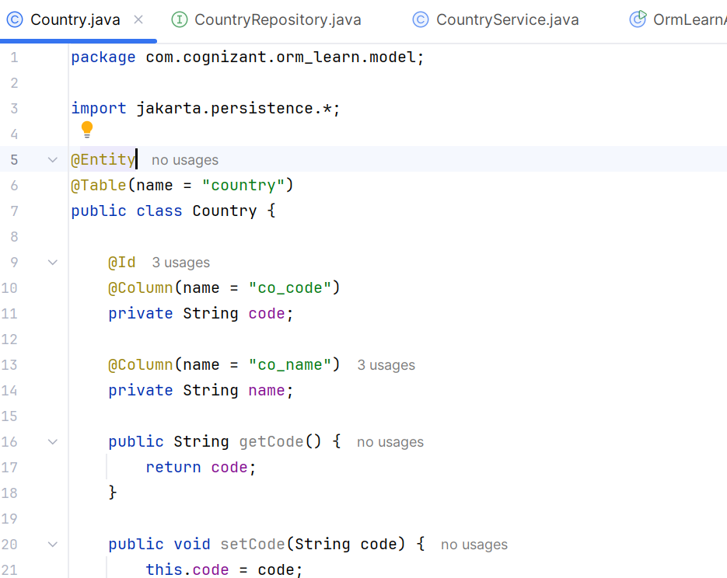

**Step 4 Repository Class - com.cognizant.orm-learn.CountryRepository**

package com.cognizant.orm_learn.repository;  
  
import com.cognizant.orm_learn.model.Country;  
import org.springframework.data.jpa.repository.JpaRepository;  
import org.springframework.stereotype.Repository;  
  
@Repository  
public interface CountryRepository extends JpaRepository<Country, String> {  
}

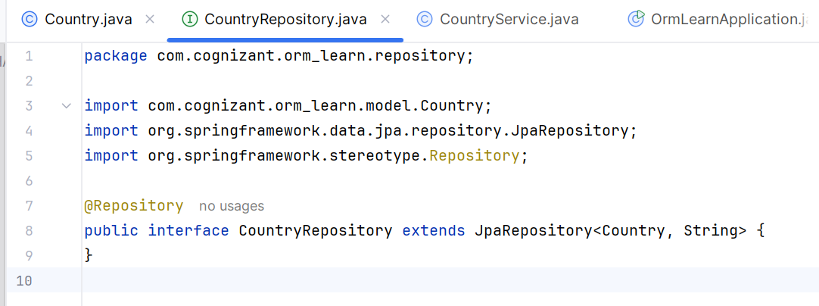

**Step 4 : Service Class - com.cognizant.orm-learn.service.CountryService**

package com.cognizant.orm_learn.service;  
  
import com.cognizant.orm_learn.model.Country;  
import com.cognizant.orm_learn.repository.CountryRepository;  
import org.springframework.beans.factory.annotation.Autowired;  
import org.springframework.stereotype.Service;  
import org.springframework.transaction.annotation.Transactional;  
  
import java.util.List;  
  
@Service  
public class CountryService {  
  
 @Autowired  
 private CountryRepository countryRepository;  
  
 @Transactional  
 public List<Country> getAllCountries() {  
 return countryRepository.findAll();  
 }  
}

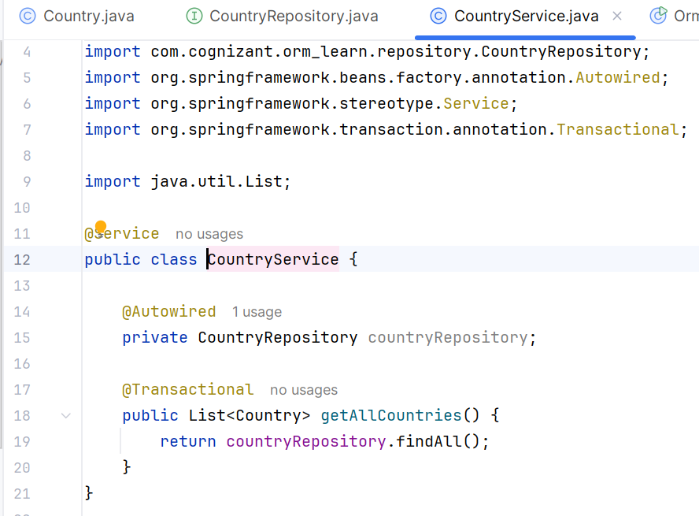

**Main class :**

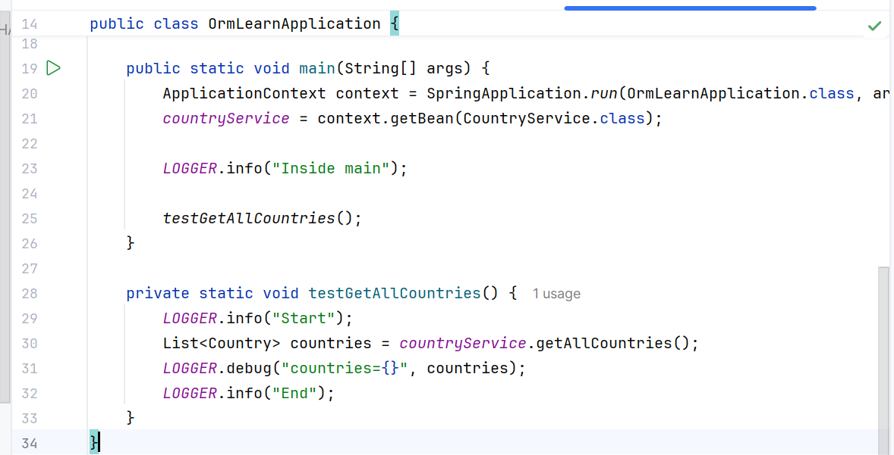

**OUTPUT :**

